Supplementary Information

Table S1. Papers used in fertilisation and survivorship analysis.

|  |  |  |  |  |  |  |
| --- | --- | --- | --- | --- | --- | --- |
| **Author** | **Year** | **Paper Title** | **Species** | **Factor** | **Life History Stage** | **Common Environmental Source of Pollutant** |
| Baird, A. H., Gilmour, J. P., Kamiki, T. M., Nnaka, M., Pratchett, M. S., Yamamoto, H. H. and Yamasaki, H. | 2006 | Temperature tolerance of symbiotic and non-symbiotic coral larvae | *Acropora muricata* | Temperature | Survivorship | Rising global temperature as a result of climate change (greenhouse effect) |
| Bassim, K. M. and Sammarco, P. W | 2003 | Effects of temperature and ammonium on larval development and survivorship in a scleractinian coral (*Diploria strigosa*) | *Diploria strigosa* | Temperature and ammonium | Survivorship | Temperature – increase global temperatures from climate change  Ammonium – as run-off from agricultural activity (fertilisers, organic matter) |
| Chua, CM., Leggat, W., Moya, A. and Baird, A. H. | 2013 | Near-future reduction in pH will have no consistent ecological effects on the early life-history stages of reef corals | *Acropora tenuis, Acropora millepora* | Acidification | Survivorship | Increased atmospheric carbon dioxide from burning fossil fuels (climate change) |
| Chua, CM., Leggat, W., Moya, A. and Baird, A. H. | 2013 | Temperature affects the early life history stages of corals more than near future ocean acidification | *Acropora tenuis, Acropora millepora* | Acidification | Fertilisation | Increased atmospheric carbon dioxide from burning fossil fuels (climate change) |
| Cox, E. F. and Ward, S. | 2002 | Impact of elevated ammonium on reproduction in two Hawaiian | *Pocillopora damicornis* | Ammonium | Survivorship | Agricultural run-off from excessive use of fertilisers, untreated manure and organic matter |
| Erftemeijer, P. L. A., Hagedorn, M., Laterveer, M., Craggs, J. and Guest, J. R. | 2012 | Effects of suspended sediment on fertilisation success in the scleractinian coral *Pectinia lactuca* | *Pectnia lactuca* | Suspended sediment | Fertilisation | Increased urbanisation and agriculture has led to more run-off carrying sediment into the ocean |
| Farina, O., Ramos, R., Bastidas, C. and Garcia, E. | 2008 | Biohemical reposne of cnidarian larvae to mercury and benzo(a)pyrene exposure | *Porites astreoides* | Mercury | Survivorship | Sourced from industry in coal-fired plants and in sewerage |
| Gilmour, J. | 1999 | Experimental investigation into the effects of suspended sediment on fertilisation, larval survival and settlement in a scleractinian coral | *Acropora digitfera* | Suspended sediment | Fertilisation | Increased urbanisation and agriculture has led to more run-off carrying sediment into the ocean |
| Harrison, P. L. and Ward, S. | 2001 | Elevated levels of nitrogen and phosphorus reduce fertilisation success of gametes from scleractinian reef corals | *Acropora longicyathus*  *Goniastrea aspera* | Ammonium, phosphorous, ammonium and phosphorous | Fertilisation | Agricultural run-off from fertilisers, manure and organic matter |
| Hartman, A. C., Marhaver, K. L., Chamberland, V. F., Sandin, S. A. and Vermeij, M. J. A. | 2013 | Large birth size does not reduce negative latent effects of harsh environments across life stages in two coral species | *Montastraea faveolata*  *Agaricia humilis* | Salinity and temperature | Survivorship | Salinity - Increased freshwater influxes from increased storm occurrences as a result of climate change  Temperature - Rising global temperature as a result of climate change (greenhouse effect) |
| Humphrey C., Weber, M., Lott, C., Cooper, T., Fabricius, K. | 2008 | Effects of suspended sediments, dissolved inorganic nutrients and salinity on fertilisation and embryo development in the coral *Acropora millepora* | *Acropora millepora* | Sediment, salinity, nitrate and ammonium | Fertilisation | Suspended sediment – increased run-off from urban areas  Salinity – increased freshwater influxes from increased storm occurrences as a result of climate change  Nitrates and ammonium – run-off from agriculture and the use of fertilisers |
| Nakamura, M., Ohki, S., Suzuki, A. and Sakai, K. | 2011 | Coral Larvae under Ocean Acidification- Survival, Metabolism, and Metamorphosis | *Acropora digitfera* | Acidification | Survivorship | Increased atmospheric carbon dioxide from burning fossil fuels (climate change) |
| Negri, A. P. and Heyward, A. J. | 2001 | Inhibition of coral fertilisation and larval metamorphosis by tributyltin and copper | *Acropora millepora* | Copper and tributyltin | Fertilisation | From their use in marine anti-fouling paints as well as from industry (smelters) |
| Randall, C. J. and Szmant, A. M. | 2009 | Elevated temperature reduces survivorship and settlement of the larvae of the Caribbean scleractinian coral, *Favia fragum (Esper)* | *Favia fragum* | Temperature | Survivorship | Rising global temperature as a result of climate change (greenhouse effect) |
| Reichelt-Brushett, A. J.and Harrison, P. L. | 1999 | The Effect of Copper, Zinc and Cadmium on Fertilisation Success of Gametes from Scleractinian Reef Corals | *Goniastrea aspera* | Copper, zinc and cadmium | Fertilisation | Copper – industrial uses in smelters, run-off from land waste and anto-fouling paint  Zinc – industrial uses in mining and the manufacture of zinc  Cadmium – manufacturing and use in disposable products (electronics) |
| Reichelt-Brushett, A. J. and Harrison, P. L. | 2004 | Development of a Sublethal Test to Determine the Effects of Copper and Lead on Scleractinian Coral Larvae | *Goniastrea aspera* | Copper and lead | Survivorship | Copper – industrial uses in smelters and anti-fouling paints  Lead – extracted from gasoline, aerosols and smelters |
| Reichelt-Brushett, A. J. and Harrison, P. L. | 2005 | The effect of selected trace metals on the fertilisation success of several scleractinian coral species | *Goniastrea retiformis, Goniastrea aspera, Acropora tenius, Acropora longicyathus* | Copper, cadmium, nickel, zinc | Survivorship | Copper – industrial uses in smelters, run-off from land waste and anti-fouling paint  Cadmium – manufacturing and use in disposable products (electronics)  Nickel – combustion of coral and oil, sewerage, mining and steel manufacture  Zinc – industrial uses in mining and the manufacture of zinc |
| Scott, A., Harrison, P. L. and Brooks, L. O. | 2013 | Reduced salinity decreases the fertilisation success and larval survival of two scleractinian coral species | *Acropora millepora, Platygyra daedalea* | Salinity | Fertilisation and survivorship | Increased freshwater influxes from increased storm occurrences as a result of climate change |
| Vermeij, M. J. A., Fogarty, N. D. and Miller, M. W. | 2006 | Pelagic conditions affect larval behaviour, survival and settlement patterns in the Caribbean coral *Montastraea faveolata* | *Montastraea faveolata* | Salinity | Survivorship | Increased freshwater influxes from increased storm occurrences as a result of climate change |
| Victor, S. and Richmond, R. H. | 2005 | Effect of copper on fertilisation success in the reef coral *Acropora surculosa* | *Acropora surcolosa* | Copper | Fertilisation | Industrial uses in smelters, run-off from land waste and anti-fouling paint |

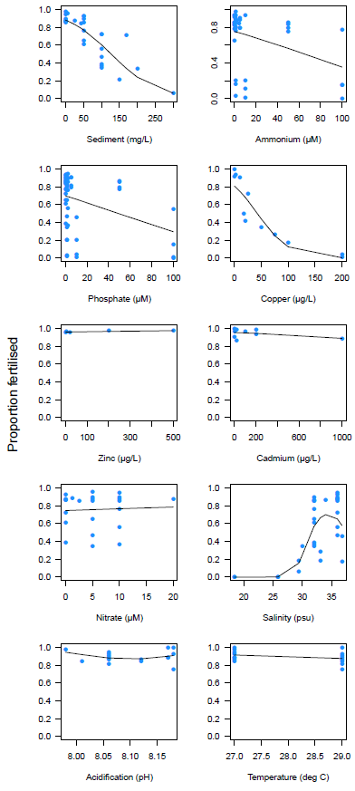Figure S1.

Figure S1. Fertilisation success as a function of each factor used to test for normality prior to being input into the full GLMM.

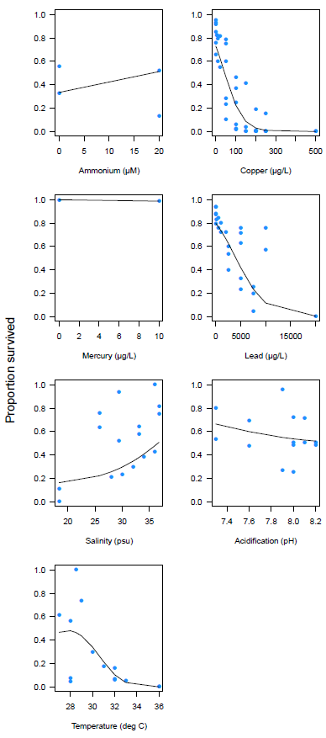Figure S2.

Figure S2. Larval survivorship as a function of each factor used to test for normality prior to being input into the full GLMM.

**Equation 1 – Fertilisation success**

$∝ = -17.6355-4.9171 \left(\frac{S-0.3}{300-0.3}\right)-1.2742 \left(\frac{A-0.1}{100-0.1}\right)-1.5390 \left(\frac{P-0.1}{100-0.1}\right)$-6.4783 $\left(\frac{C-2}{200-2}\right)+42.3975 \left(\frac{Sa-18.4}{36.8-18.4}\right)$

**Equation 1 – Survivorship**

$∝ = -3.682-15.708\left(\frac{C-5}{500-5}\right)-6.205\left(\frac{L-20}{20000-20}\right)+9.289\left(\frac{Sa-18.4}{36.8-18.4}\right)$

**Equation 2 – Inverse logit**

P = $\frac{exp⁡(∝)}{\exp\left(∝\right)+1}$